**Supplemental Data**

**Table S1.** Least squared means for grain yield, protein, and grain N yield for the main effects of plant density, nitrogen (N) application timing, and plant growth regulator (PGR) application of chlormequat chloride (CCC) as well as their interactions with site-year.

|  |  |  |  |  |  |  |  |  |  |  |  |  |  |  |  |  |
| --- | --- | --- | --- | --- | --- | --- | --- | --- | --- | --- | --- | --- | --- | --- | --- | --- |
|  |  | **Grain Yield** | | | | | **Grain Protein Concentration** | | | | | **Grain N Yield** | | | | |
|  |  | Car18 | Car19 | Man18 | Man19 | **Mean** | Car18 | Car19 | Man18 | Man19 | **Mean** | Car18 | Car19 | Man18 | Man19 | **Mean** |
|  | | kg ha-1 | | | | | % | | | | | kg N ha-1 | | | | |
| **Plant Density** | |  |  |  |  |  |  |  |  |  |  |  |  |  |  |  |
|  | Low | 5726 b† | 4739 | 5318 | 4649 | **5108** | 14.1 | 14.3 | 14.2 | 14.4 | **14.3** | 141 | 119 | 133 | 117 | **128** |
|  | Med | 5654 b | 4467 | 5392 | 4760 | **5068** | 14.4 | 14.5 | 13.9 | 14.1 | **14.2** | 143 | 114 | 131 | 118 | **126** |
|  | High | 6083 a | 4572 | 5372 | 4504 | **5133** | 14.0 | 14.4 | 14.0 | 14.0 | **14.1** | 150 | 116 | 131 | 110 | **127** |
| **Nitrogen Timing** | |  |  |  |  |  |  |  |  |  |  |  |  |  |  |  |
|  | Planting | 5767 | 4598 | 5432 | 4686 | **5121** | 14.0 | 14.2 | 13.7 | 13.9 | **13.9 b** | 141 | 114 | 130 | 114 | **125 b** |
|  | Split | 5875 | 4587 | 5289 | 4590 | **5085** | 14.4 | 14.7 | 14.4 | 14.4 | **14.5 a** | 148 | 118 | 133 | 116 | **139 a** |
| **PGR** | |  |  |  |  |  |  |  |  |  |  |  |  |  |  |  |
|  | Untreated | 5796 | 4431 | 5298 | 4569 | **5024 b** | 14.3 | 14.5 | 14.1 | 14.1 | **14.2** | 145 | 112 | 131 | 113 | **125 b** |
|  | CCC | 5846 | 4754 | 5423 | 4707 | **5182 a** | 14.1 | 14.4 | 13.9 | 14.1 | **14.2** | 144 | 120 | 132 | 117 | **128 a** |

† Within columns, and main effects, means followed by the same letter are not significantly different at the 0.05 probability level; absence of letters indicates no significant differences within columns

**Table S2**. Least squared means for the site-year by low (target 150 plants m-2), medium (target 250 plants m-2), and high (target 350 plants m-2) plant density interaction for spike density.

|  |  |  |  |  |
| --- | --- | --- | --- | --- |
| Spike Density | Site-year | | | |
|  | Car18 | Car19 | Man18 | Man19 |
|  | spikes m-2 | | | |
| Low | 466 b† | 459 | 409 | 457 |
| Medium | 485 ab | 444 | 409 | 443 |
| High | 522 a | 439 | 406 | 423 |
| ANOVA *p*-value (SY*PD) | | 0.0133 | | |

† Within columns means followed by the same letter are not significantly different at the 0.05 probability level; absence of letters indicates no significant differences within columns

**Table S3**. Least squared means for the interaction of low (target 150 plants m-2), medium (target 250 plants m-2), and high (target 350 plants m-2) plant density and the plant growth regulator (PGR) application of chlormequat chloride (CCC) on total above-ground dry matter at anthesis.

|  |  |  |  |  |  |  |
| --- | --- | --- | --- | --- | --- | --- |
|  | Total DM at Anthesis | | | | | |
| PGR Application | Plant Density | | | | | |
|  | Low | | Med | | High | |
| kg ha-1 | | | | | | |
| Untreated | 4780 |  | 4980 | a† | 4880 |  |
| CCC | 4930 |  | 4630 | b | 4620 |  |

†Within columns, and main effects, means followed by the same letter are not significantly different at the 0.05 probability level; absence of letters indicates no significant differences within columns

**Table S4**. Pearson correlation matrix (r values) performed on individual plot data for yield, protein, grain nitrogen (N) yield, vegatative dry matter (stem + leaf tissue) at anthesis (Veg DM AN), leaf area index (LAI), canopy height, N uptake at anthesis, N remobilization (NRm), post-anthesis (PA) N uptake, visual lodging ratings, stem strength measured at anthesis (AN) and maturity (MT), as well as days to anthesis (DTA) and grain fill duration (GFD).

|  |  |  |  |  |  |  |  |  |  |  |  |  |  |  |  |
| --- | --- | --- | --- | --- | --- | --- | --- | --- | --- | --- | --- | --- | --- | --- | --- |
|  | *n* | Yield | Protein | Grain N Yield | Veg DM AN | LAI | Heights | N Uptake AN | NRm | PA Uptake | Lodging Rating | Strength AN | Strength MT | DTA | GFD |
| Yield | *191* | 1 |  |  |  |  |  |  |  |  |  |  |  |  |  |
| Protein | *191* | -0.03*** | 1 |  |  |  |  |  |  |  |  |  |  |  |  |
| Grain N | *191* | 0.94*** | 0.06 | 1 |  |  |  |  |  |  |  |  |  |  |  |
| Veg DM AN | *191* | 0.05 | 0.05 | 0.06 | 1 |  |  |  |  |  |  |  |  |  |  |
| LAI | *96* | 0.06 | -0.23* | -0.06 | 0.01 | 1 |  |  |  |  |  |  |  |  |  |
| Heights | *192* | -0.00 | -0.07 | -0.02 | 0.31*** | -0.06 | 1 |  |  |  |  |  |  |  |  |
| N Uptake AN | *191* | 0.43*** | -0.03 | 0.43*** | 0.82*** | -0.01 | 0.14* | 1 |  |  |  |  |  |  |  |
| NRm | *192* | 0.42*** | -0.01 | 0.43*** | 0.75*** | -0.14 | 0.12 | 0.92*** | 1 |  |  |  |  |  |  |
| PA Uptake | *189* | 0.38*** | -0.03 | 0.39*** | -0.41*** | 0.14 | -0.21* | -0.19* | -0.27*** | 1 |  |  |  |  |  |
| Lodging | *192* | -0.22** | -0.15* | -0.27*** | 0.08 | 0.17 | 0.04 | -0.06 | -0.15* | -0.19** | 1 |  |  |  |  |
| Strength AN | *96* | 0.25** | -0.03 | 0.23* | -0.20 | -0.00 | 0.16 | -0.07 | -0.06 | 0.21* | -0.19 | 1 |  |  |  |
| Strength MT | *191* | 0.65*** | -0.09 | 0.64** | -0.04 | 0.05 | -0.21** | 0.31*** | 0.34*** | 0.41*** | -0.23** | 0.14 | 1 |  |  |
| DTA | *192* | -0.27*** | 0.08 | -0.26*** | 0.16* | -0.25* | 0.33*** | 0.10 | 0.10 | -0.23** | -0.29*** | 0.32** | -0.14 | 1 |  |
| GFD | *192* | 0.54*** | -0.12 | 0.52*** | 0.15* | 0.05 | 0.11 | 0.45*** | 0.39*** | 0.32*** | -0.19* | 0.01 | 0.52*** | 0.05 | 1 |

* Significant at the 0.05 probability level

** Significant at the 0.01 probability level

*** Significant at the 0.0001 probability level

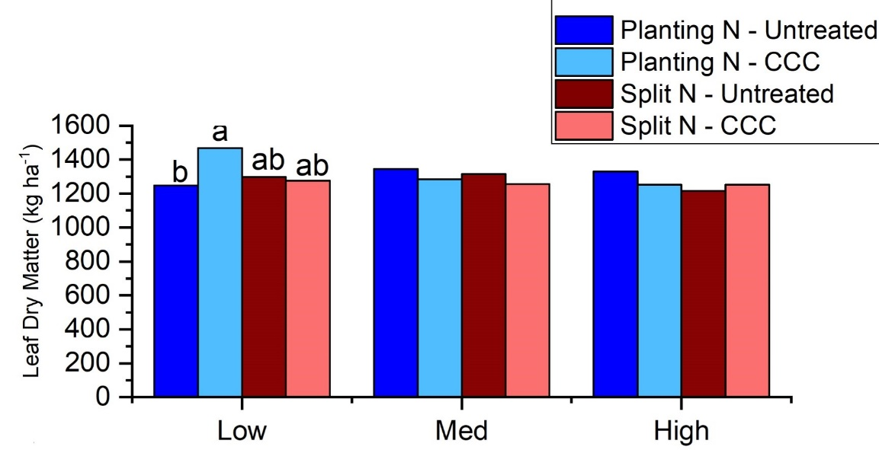

**Figure S1.** Interaction of low (target 150 plants m-2), medium (target 250 plants m-2) and high (target 350 plants m-2) plant densities with the plant growth regulator (PGR) application of chlormequat chloride (CCC) and nitrogen (N) fertilizer application timing for leaf tissue dry matter (DM) at anthesis. Bars with similar letters within each plant density treatment indicate no significant difference at the 0.05 probability level.