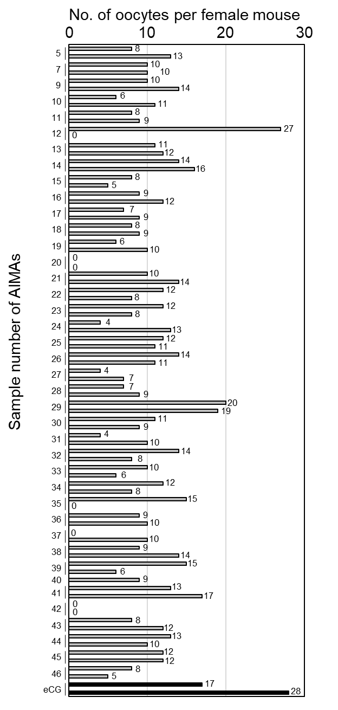

**Supplemental Figure S1.**

Results of screening test for superovulation after injection of different AIMAs. The number of oocytes collected from 1–2 females for each AIMA is indicated by a gray bar. The black bars show results of the standard superovulation method using equine chorionic gonadotropin (eCG).

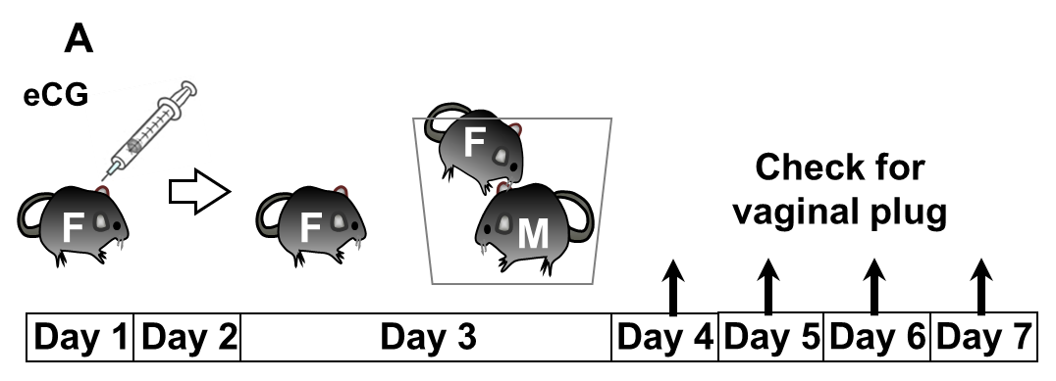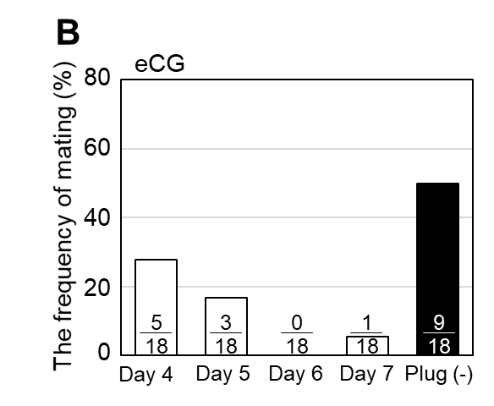

**Supplemental Figure S2.**

(A) Schematic representation of superovulation with eCG alone. After the injection, each female (F) was paired with a male mouse (M) from the evening of Day 3. The females were checked for the presence of a vaginal plug during the mornings of Days 4–7.

(B) Distribution of the days of mating after continuous pairing with male mice. Values within the bars are the numbers of females with a vaginal plug among the total tested (n = 18).

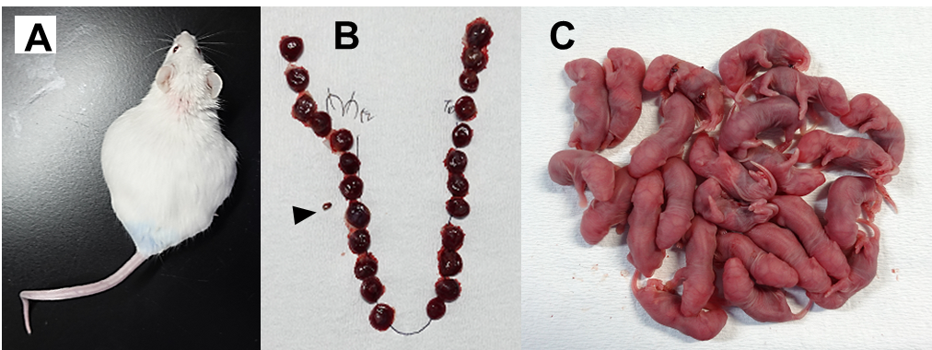

**Supplemental Figure S3.**

(A) AIMA-treated pregnant ICR female immediately before cesarean section.

(B) After cesarean section, the placentas removed from the uterus were placed in their original order. The arrowhead indicates one resorption site.

(C) A litter of pups (n = 24) obtained from one ICR female.